# **Natural Gas Energy Balance 2017**

## Main data sources

The South African Gas Energy Balance was constructed using The Department of Mineral Resources and Energy (DMRE) 2017 gas energy balance [1] as a starting point. However, since discrepancies existed and gaps lay within this data set, the DMRE balance was combined with other sources of information and data to capture the best available information and ensure that all the gas in the system was accounted for. The main additional data sources used in the energy balance development included:

* Statistics SA 2016 and 2019 total gas purchases for South Africa table [2]
* National Business Initiative (NBI) [3]
* Sasol 2017 Additional Analyst Information Report (2017a) [4] and Sasol Annual Emissions Report (2017b)

## Key points considered and assumptions made

To develop the completed Natural Gas Energy Balance, various assumptions were made. These are listed below along with key points to highlight for the energy balance construction:

* The “methane-rich gas” 2016 and 2019 purchase values from *StatsaSA Purchases of gas in the electricity, gas and water supply industry, 2016 and 2019* table [2] were used for the natural gas energy balance “Indigenous Production Byproduct” StatsSA supply values.
* Natural gas that was consumed in a ‘transformation’ process instead of as final energy was accounted for as a negative value in the natural gas energy balance.
* From the DMRE 2017 dataset, the “Natural Gas” values were used for “Indigenous Production”, “Domestic Supply”, “Transformation Sector”, “Liquefaction” and “Ownuse in Elec, CHP and Power” sectors of the natural gas energy balance.
* For the “Industry”, “Chemicals” and “Others” sectors in the natural gas energy balance, the sum of the “Natural Gas” and “Gasworks Gas” values from the DMRE 2017 dataset were used.
* To develop an extensive energy balance for SATIMGE-2022 where supply matches consumption, additional sources were consulted:
* The “Indigenous Production Byproduct” and “Import” supply values were assumed to be those from Sasol 2017a [4].
* The supply quantity of “Oil Refineries (Natref)” in the “Transformation Sector” was assumed to be that from Sasol 2017b.
* The “Ammonia Production” quantity was an estimation derived from Sasol 2017b by using an assumption from USDA 2007 [5] which stated that approximately 33 million British thermal units of natural gas were needed to produce 1 ton of ammonia.
* In the “Ownuse in Elec, CHP and Heat” sector, both “Secuda (CTL)” and “Sasolburg (Chemicals)” supply quantities were derived from Sasol 2017b and NERSA 2017. NERSA provided the electricity produced by both Sasol gas power plants (Secunda- 1 758 GWh and Sasolburg- 794.6 GWh). Thereafter, an efficiency of 33% for Secunda OCGT’s was assumed and 45% for Sasolburg’s gas engines.
* The “Chemicals” sector “Sasol boilers (combustion)” consumption value was taken from Sasol 2017b while the “Sasol material use (excluding Ammonia)” was taken from Sasol 2017a.
* For “Boilers (combustion) excluding Sasol” and “Material Use excluding Sasol” consumption quantities, a 50/50 split was assumed. The values were calculated by deducting all “Industry sector” and “Other sector” consumption values from the “external sales” value of Sasol 2017a [4] and dividing this by 2. The material use excluding Sasol consumption value was estimated …

## Preliminary Energy Balance including all considered sources

Table : Preliminary 2017 Natural Gas Energy Balance



## Adopted Energy Balance as per SATIM sector/ subsector disaggregation

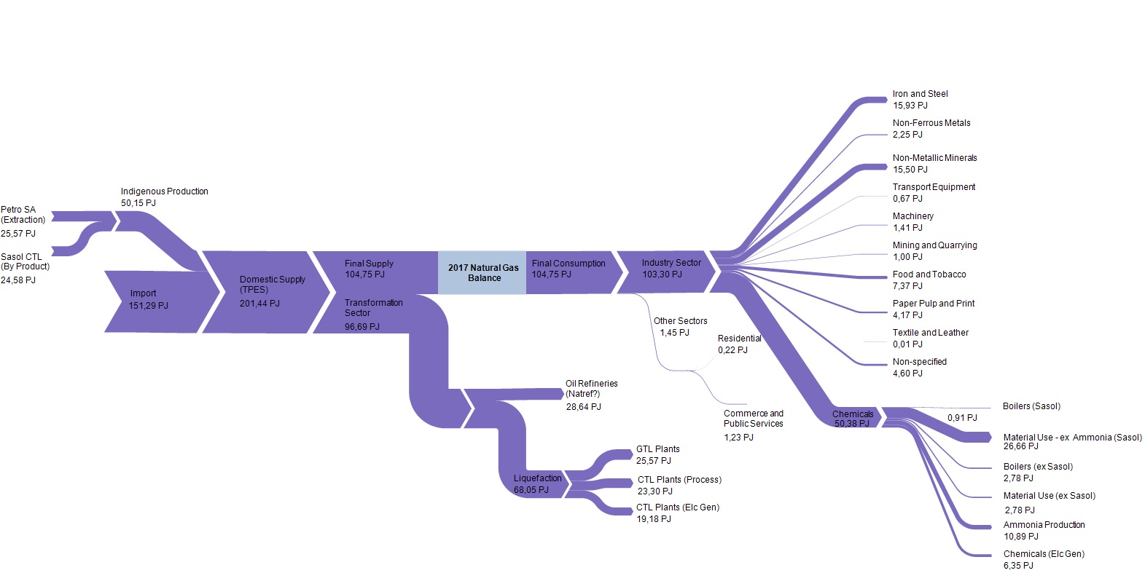

Figure : 2017 Natural Gas Energy Balance Sankey Diagram (PJ)

Table : 2017 Natural Gas Energy Balance SATIMGE-2022

## 

## Identified gaps for future work

## References

[1] “DMRE Gas Energy Balance 2017,” 2017.

[2] R. Maluleke, “Electricity, gas and water supply industry, 2019,” 2019. [Online]. Available: www.statssa.gov.za.

[3] N. B. Initiative, “Just Transition and the Role of Gas in South Africa’s Path to Net-Zero.” [Online]. Available: ww.nbi.org.za.

[4] “Sasol: Additional analyst information,” no. December, 2017, [Online]. Available: https://www.sasol.com/sites/default/files/financial_reports/Additional Analyst Information - 31 December 2017.pdf.

[5] W. Huang, “Impact of Rising Natural Gas Prices on U . S . Ammonia Supply,” *USDA*, vol. WRS-0702, 2007, [Online]. Available: https://www.ers.usda.gov/webdocs/outlooks/40459/11717_wrs0702_1_.pdf?v=3385.2#:~:text=Natural gas is the primary,produce 1 ton of ammonia.